1. In the below elements which of them are values or an expression? eg:- values can be integer or string and expressions will be mathematical operators.

\* - expression

'hello'- values

-87.8- values

- - expression

/ - expression

+ - expression

6 - values

2. What is the difference between string and variable?

String- It is value assign to any variable in single quote (‘ ’) or double quote (“ ”)

Variable- It is reserve memory in system to store values which can very as per the requirement.

For Ex X= “Hello world”

X is Variable and

Hello world is string.

3. Describe three different data types.

Numbers – 43, 3 +4j, 3.5

Boolean True or False

Strings- “Sawan”

4. What is an expression made up of? What do all expressions do?

Expression is made up of values, containers, and mathematical operators (operands) e.g y=x+3

5. This assignment statements, like spam = 10. What is the difference between an expression and a statement?

A statement performs certain action (does something), an expression evaluates to a value.

Ex- a=100 (statement),, a=100\*10 (expression)

6. After running the following code, what does the variable bacon contain?

bacon = 22

bacon + 1

- 23

7. What should the values of the following two terms be?

'spam' + 'spamspam'- 'spamspamspam'

'spam' \* 3- 'spam' + 'spamspam'

8. Why is eggs a valid variable name while 100 is invalid?

Any alpha or alpha numeric can be variable like a, abc, abc1, eggs

However, 100 is defined value and cannot be use as variable

9. What three functions can be used to get the integer, floating-point number, or string version of a value?

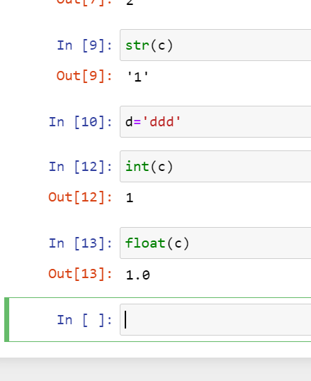

10. Why does this expression cause an error? How can you fix it?

'I have eaten ' + 99 + ' burritos.'

* String function can not be added to integer.
* It can be corrected if integer can be converted to string as below
* 'I have eaten ' + ‘99’ + ' burritos’ => 'I have eaten 99 burritos’